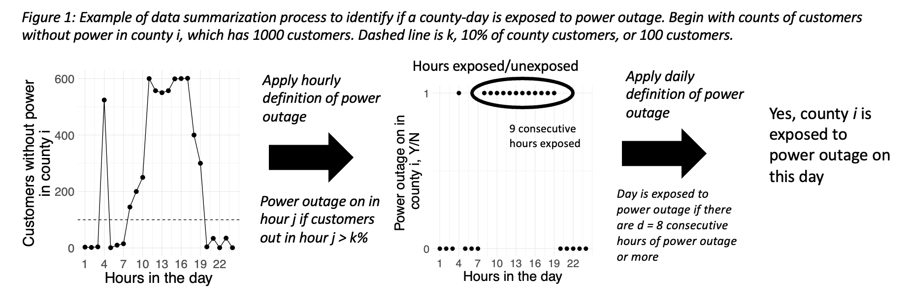

**Figure 1**: Example of data summary process to identify if a county-day were exposed to a power outage. In this example, county *i* has 1000 customers. The leftmost plot shows counts of customers without power in county *i* for each hour of the day in question. The dashed line on the leftmost plot represents *k*,the cut point after which an hour is considered exposed to power outage (10% in this case, or 100 customers). The center plot shows hours exposed/unexposed to power outage, with 9 consecutive hours of the 24 hours exposed.Because this is longer than 8 hours, the specified duration, this day would be considered exposed to power outage.